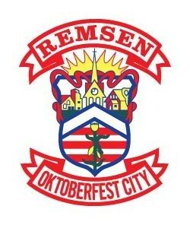

REMSEN OKTOBERFEST
SATURDAY, OCTOBER 28th, 2023
CONTEST BEGINS AT 1:30 PM – RSM GYMNASIUM

THE 2023 CHILDREN’S BAVARIAN COSTUME & DANCE CONTEST WILL BE HELD AT THE REMSEN ST. MARY’S GYMNASIUM AT 1:30 PM ON SATURDAY, OCTOBER 28^{th.} CHILDREN IN GRADES PK-6th WILL BE JUDGED ON LUXEMBOURG ATTIRE AND EVENT PARTICIPATION. CHILDREN AGES 4 AND UNDER ARE ENCOURAGED TO DRESS UP AND JOIN IN ON THE FUN! OUR NEWLY CROWNED PRINCE AND PRINCESS WILL EACH RECEIVE $50 AND EVERYONE THAT PARTICIPATES WILL GET A GIFT BAG FROM THE OKTOBERFEST COMMITTEE. CONTESTANTS ARE ASKED TO MEET IN THE RSM GYM AT 12:30 PM FOR A DANCE LESSON AND CONTEST PREPARATION.
IF YOU HAVE ANY QUESTIONS, PLEASE CONTACT ONE OF THE FOLLOWING COMMITTEE MEMBERS:
Lydia Donovan (712) 540-9071; lydia_donovan@outlook.com | Samantha Decker (712) 540-8365; samantha_theisen2@hotmail.com
Sue Theisen: (712) 540-6136; sue_theisen@hotmail.com



PLEASE COMPLETE THE BOTTOM PORTION OF THIS REGISTRATION FORM AND RETURN TO
YOUR SCHOOL OFFICE BY FRIDAY, OCTOBER 14th. (PHOTOGRAPH IS ALSO REQUESTED)
CHILDREN’S BAVARIAN COSTUME & DANCE CONTESTANT:
NAME: ____________________________________

AGE: ______________GRADE: ________________
PARENTS: _________________________________

PARENT PHONE #: _________________________

PARENT EMAIL: ___________________________

“IN MY OWN WORDS”

I LIKE LIVING IN REMSEN BECAUSE….……..
______________________________________________________________________________________________________________________________________________________________________________________________________

REMSEN OKTOBERFEST IS ………..
______________________________________________________________________________________________________________________________________________________________________________________________________

IF I’M PICKED TO BE THE PRINCE OR PRINCESS, I WILL…
____________________________________________________________________________________________________________________________________
TEACHERS/PARENTS: This is the Oktoberfest shield, which symbolizes the German and Luxembourg heritage of the Remsen community. As we approach our 49th annual Remsen Oktoberfest celebration, which will be held on Saturday, October 28th 2023, please take a moment to educate your children about their heritage. Please encourage them to color this shield, and return it to the SCHOOL OFFICE by Friday, October 13th. All artwork will be used to decorate the halls at the Remsen St. Mary’s high school on Oktoberfest day. Thank you for your assistance in carrying on our annual tradition!
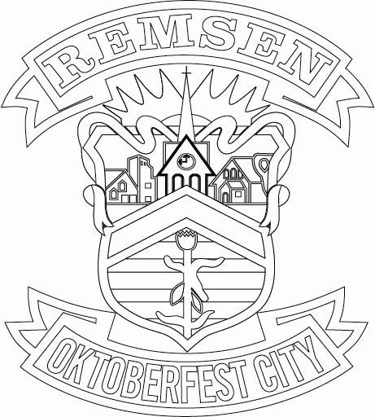
ARTIST: _______________________________ GRADE: ________ AGE: ______
PARENTS: __________________________________________________________

