Office space for rent located at 262 S Washington St. Formerly used as a dental office. Area includes a waiting area, front desk area, bathroom, and more. For more information, please contact Cyril Schmit at 712-540-4908.
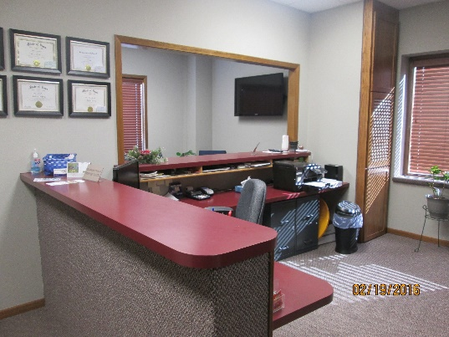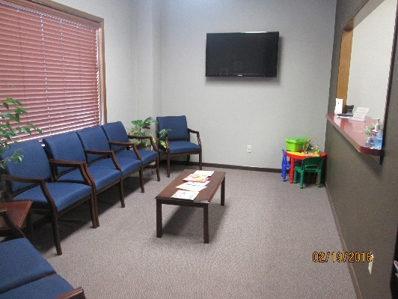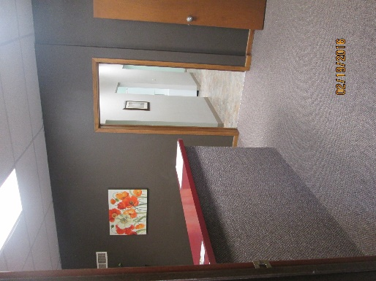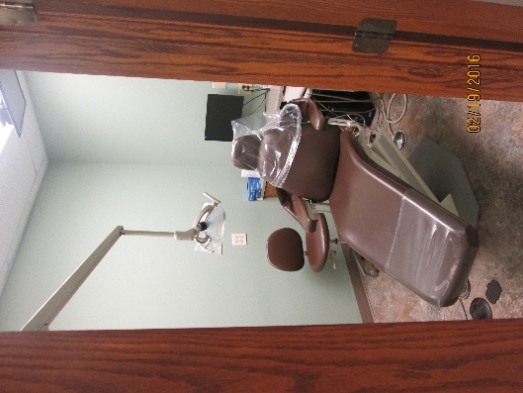

Office space for rent located at 262 S Washington St. Formerly used as a chiropractic office. Area includes a waiting area, front desk area, 2 additional offices, bathroom and storage room area. For more information, please contact Cyril Schmit at 712-540-4908.
